**Eclaramon Darven** 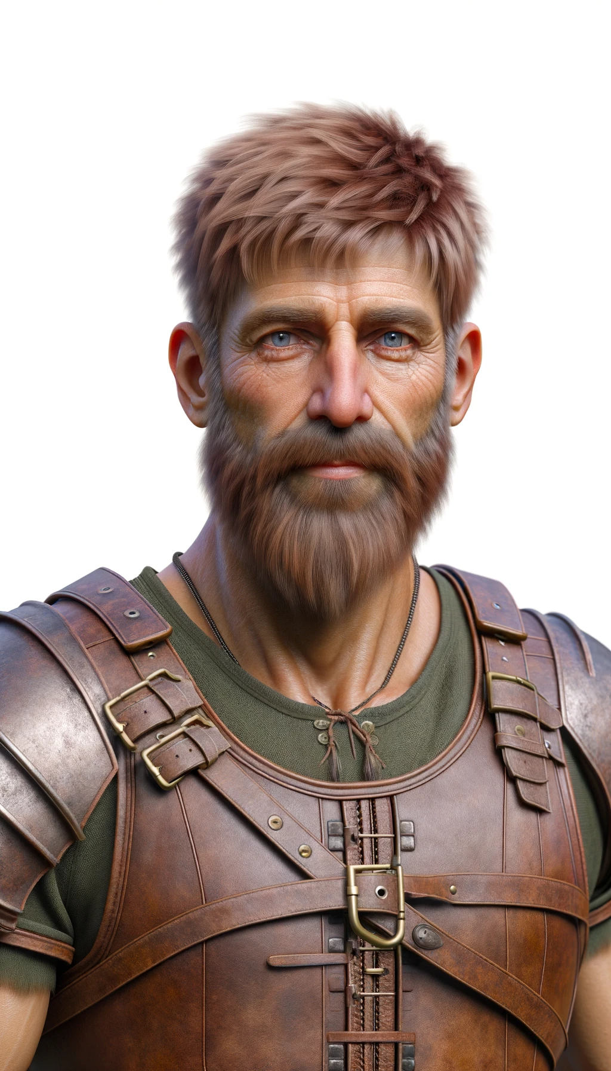

**Settlement guardsman**

**Deelth Beele**

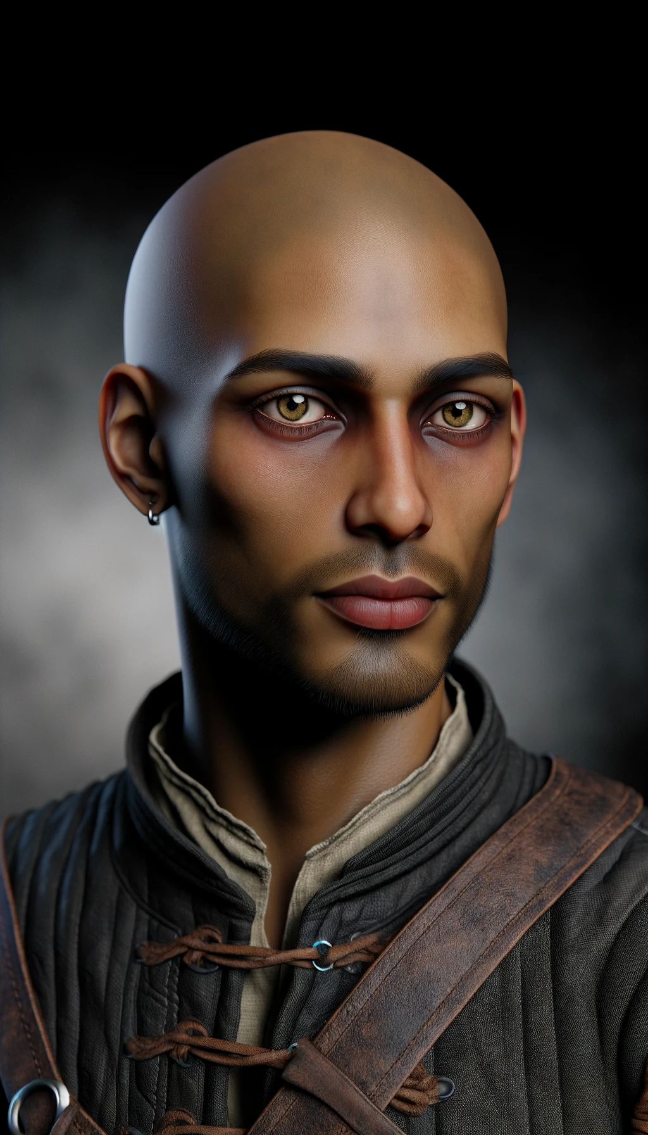

Gang member

**Daqualor Norian-Beoshar** 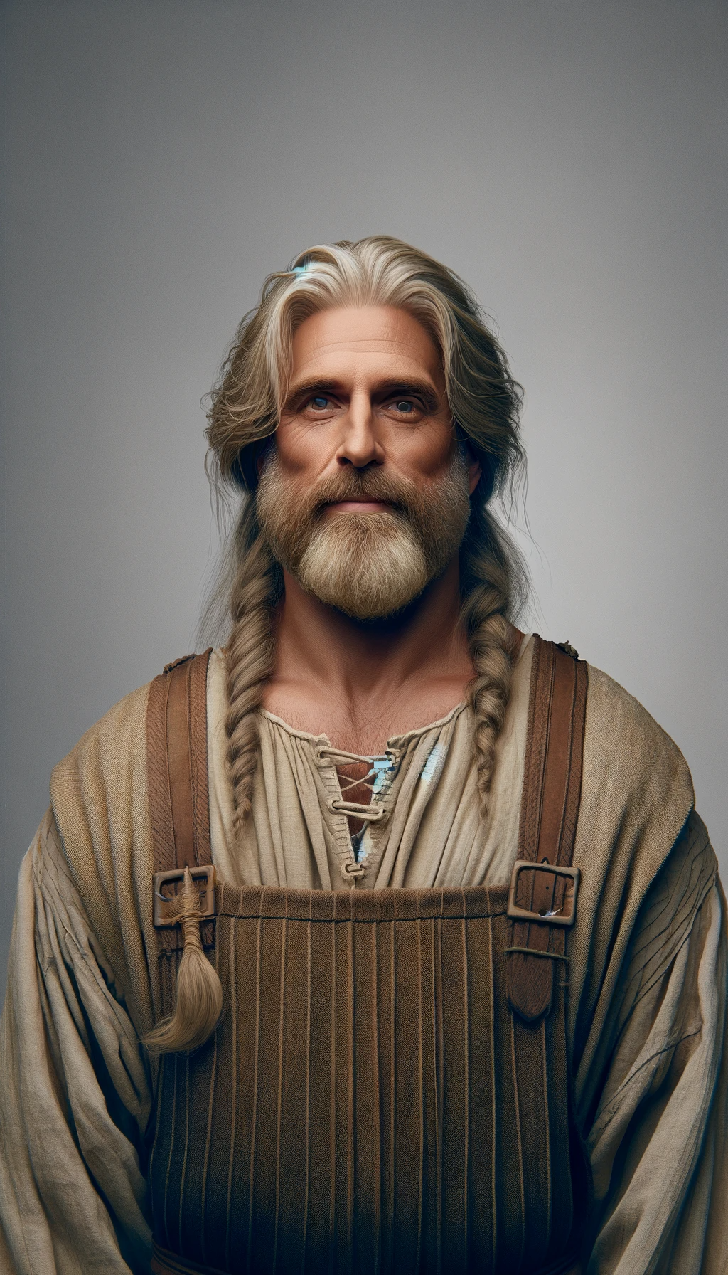

Weaver

**Chorrin Gorion**

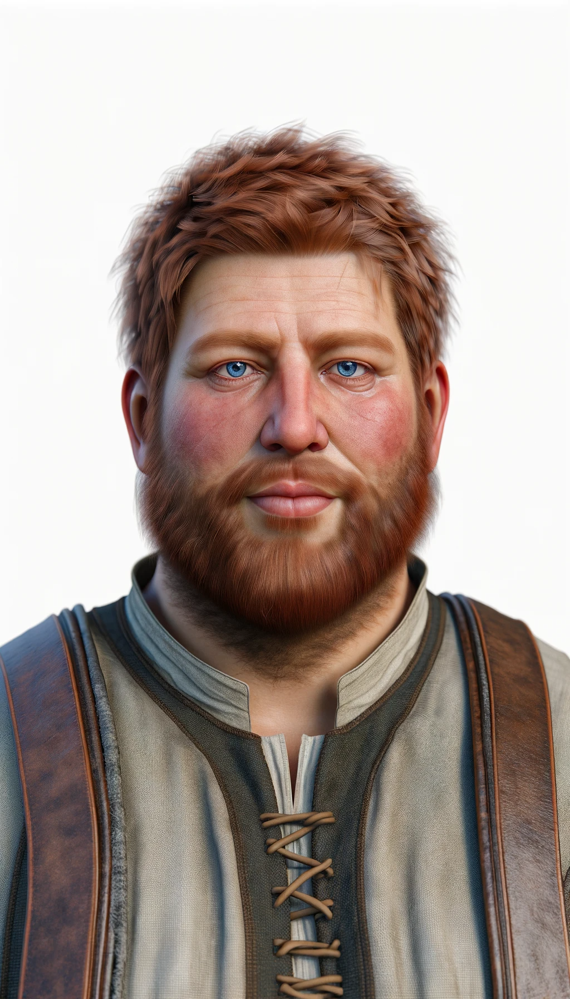

Tavern owner